SOAP NOTES

Subjective
- This section is dedicated to the qualitative information you gather from the client’s point of view.
- It is 1-2 sentences in quotation marks reflecting a statement the client made.
- Subjective data may include their perception of progress, issues they continue to struggle with, gains they feel good about, and any goals they have for future sessions.
- Opening up the session by asking how things are going can yield a rich amount of subjective data.
- Please put in the S call #/total (1/4)

- Examples:
  - “I slept 6 hours in a row recently and I haven't slept that many consecutive hours in years.”
  - “I've been doing intermittent fasting now for about two weeks. After the holidays I felt I needed it. It's amazing how much I trim so fast.”
  - ” I'm looking forward to doing my miles and at night I walk hills. That helps me a lot, I can really feel it in my bones.”

Objective
- Write the things you talked about, what they are currently doing and client’s demeanor on the call.
- Document all the things you want to remember about the client for the next call.
- Examples:
  - Met with dietitian on Thursday - 4 days ago. She gave her a list of foods she could eat.
  - She has an app that calculates food and macros.
  - Still feeling anxiety and stress from work.
  - New manager isn't communicating well.

Assessment
- Your personal opinion or feeling about the person’s motivation.
- Stages of change documented.
- Example:
  - Client is in Contemplation for snacks, circle back to cutting down own milkshakes…Circle back next call.
  - She seems to be doing well. She stays pretty consistent in the way she cares for herself.
  - She currently is concerned for her son as he is not feeling well in basketball, and she says she feels his stress.
  - She did mention that exercise consistency seems to help her sleep better.
  - In my assessment, she doesn't think this is a problem but mostly something she just accepts as what someone in night shifts struggles with.
  - I did try to talk with her about upcoming barriers like a schedule change and job change.

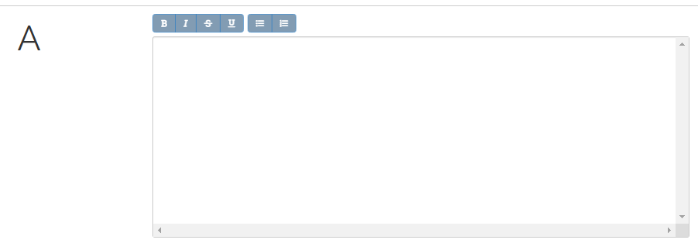
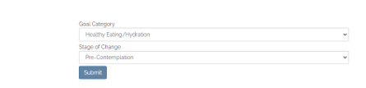
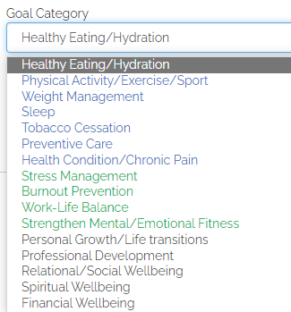
For the Goal Category DropDown box, coach should mark the PRIMARY goal of the client FIRST. Coach is allowed to choose more than one category per client; just ensure the primary goal of the client is chosen first, as this affects reporting.

Plan
- SMART goals
- What will be the goal for the next session?
  - Did the session reveal a need for any other goals to be talked about in future sessions?
  - Are there any challenges relating to the goals?
- Examples:
  - Always have on hand the types of foods you like. Grocery shop with that in mind.
  - Stay the course of replacing white rice with quinoa.
  - Aim to drink 80 ounces of water a day.
  - Continue working out 4 days a week for 30-45 minutes after work.

