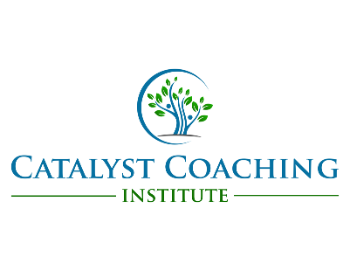

Examples of Mentor Feedback for a Student: Sessions 1-3

Session 1: General Feedback

Strengths:
- The student created great rapport throughout the conversation by listening to the client and sharing appropriate and on target reflections.
- The student used open-ended questions and reflections throughout the coaching session, and affirmed the client’s past successes.

Opportunities:
- The student asked more questions than reflections during the session.
- The student jumped to the how before exploring the why.

Session 2: More specific Feedback based on the Rubric

Strengths:
- The student used the MI OARS well to move the conversation forward and generate change talk. They did a great job affirming the client’s strengths and values.
- The student used silence and pauses to allow the client to process their reasons for change.
- The student asked about possible barriers.

Opportunities:
- The student struggled to show compassion when the client was sharing and seemed uncomfortable acknowledging the client’s emotions.
- The student summarized the client goals. There was time to let the student share goals and takeaways.

Session 3: Specific Feedback based on the Rubric. Ask yourself, “Is this student ready to pass the PSA?”

The Student is Ready for the PSA

Strengths:
- The student asked open-ended questions to promote discovery and an “AHA” moment regarding the topic that the client was talking about.
- The student used an experimental mindset when collaborating with the client to set goals and explored support and challenges.

Opportunities:
- The student needs to continue to focus on reflecting and summarizing change talk vs any talk.
- The student should continue to work on being mindful of refraining from directly offering strategies (with a guise of asking permission to share), and instead offering the strategy of brainstorming.

The Student is NOT Ready for the PSA
- The student is not able to demonstrate the MI OARS proficiently.
- The student is directive and misses what the client is communicating.
- The student shares that they are not confident and would like an additional practice session.

Next Steps if the Student is NOT Ready for the PSA
- Communicate with Susan (smcgarry@uscoporatewellness.com) that you feel the student needs an addition practice session and why.
You may want to…
- Recommend listening to the CCI Podcasts under the Hot Topic Coaching Career and Business, to a “Real Live Unscripted Coaching Session”.
- Recommend practice coaching with friends and family.

PSA:

Score using the PSA Rubric

- Record Feedback on any skill that is scored a 3 or below under coach notes.
- Give 1-2 positive feedback notes on scores of 4-5 under coach notes.
- Send me (smcgarry@uscorporatewellness.com) the scored rubric and feedback within 48 hours of the session.

