2022 USCW Coach Admin Toolbox

Table of Contents

Calendar System ………………………………….…………………………………………………………………….……. 1
- Available Appointment Times
- Client to Schedule or Reschedule an Appointment
- Automated Appointment Confirmation
- Automated Reminder Email of Scheduled Appointments
- Automated Reminder Text of Scheduled Appointments
- Delete Appointment Times
- Missed Appointment
- Vacations
- New Clients
- Transfer Clients
Technology Integration …………………………………………………………………………………………………... 7
SOAP Note Documentation …………………………………………………………………….……………..……….. 8
Reporting ………………………………………………………………………………………………………..……………… 15
- Active Client List
- View Inactive, Leave, and Terminated Clients
- View Clients’ Number of Completed Sessions by Contract
Invoice ………………………………………………………………………………………………………..…………………. 18
Miscellaneous …………………………………………………………………………………………………….….….…… 20
- Preventative Measures for Website Outage
- Setting up USCW Email Signature

Appendix ………………………………………………………………………………………………………………………… 21
- Sample Autogenerated Appointment Confirmation Email
- Sample Missed Call Email

Updated October 2022

Calendar System

Mark available appointment times:
- Log in to the website www.uscorporatewellness.com and it will take you to the Calendar.
- If you are in the ‘Month’ view, you can click in the box of the date you want to add available appointment, or click ‘Week’ on the top right of the calendar.
- Click on the time ‘box’ within that day – scroll down as many times that you have available for that day.
- Click on ‘Type’ and choose in dropdown box: ‘Available’.
- These are in 15-minute increments – You need to schedule in 30-minute increments. Once you choose a box, the computer will make the appointment 30 minutes from when it is scheduled to start.
- Please open up your calendar two months in advance- you can update these any time.
- Be aware of perception - Remember that your clients only see open appointment slots, so even if you are very full in terms of your calendar, if no slots are available then it will look to the client as if the calendar isn’t working.
Open appts select ‘appointment’
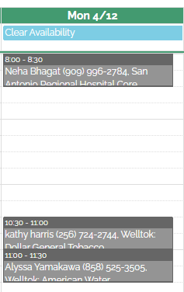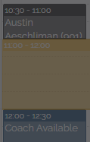
Scheduled appt

Opening blocks of time

Coach Available
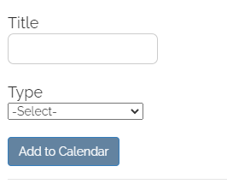

Client to Schedule or Reschedule an Appointment
      - The coach is matched when the client chooses a specific appointment time on the calendar. If more than one coach offers the same appointment slot, the site is programmed to shuffle the coach names to fairly distribute clients.
      - A client may not schedule up to 48 hours in advance. If they try to set an appointment within this 48-hour time limit, they will be asked to e-mail you directly to check for availability. Of course, they can schedule any time after the 48-hour time limit.
- Example: If today was the 15th, the client can schedule on the 17th and after.
- If a client schedules/reschedules an appointment, you will be alerted through an e-mail and an alert in your wellness journal when you first log on to the website. Simply click ‘dismiss’ to delete the alert on the site.
<Client> has added or updated their call appointment. Please sign in and use the url below to go to the date of the new appointment.
https://www.uscorporatewellness.com/member/calendar/?yr=2021&mth=3&date=16

3. A client may only schedule 1 appointment at a time.
- If you want to schedule more than 1 appointment: go to the date of the 2nd appt and “hold it” by clicking ‘Other’ and put your client’s name in it.
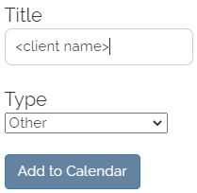
- It is not an official appointment. It is simply a place holder and the client won’t see it on your calendar.
- Note it in your SOAP notes for the call that was held. You can go and officially schedule the call after the previous call is completed.
4. To schedule or reschedule a client yourself on the calendar:
    - Click on the desired appointment time slot.
    - Type: “set appointment”
    - Click on the name of your client or begin typing the first few letters of the name and it will appear.

Automated Confirmation Email
- Once a client signs up for an appointment on the calendar, the site will automatically send them an email with details about their upcoming coaching session. (See Appendix for example)
- If they “reply” to the email, it will come directly to your USCW email inbox.
- The content of this email is specific for each company.

Automated Reminder Email of Scheduled Appointments
      - Clients will receive 2 automated reminder emails: 8 days in advance and 1 day in advance:
        - 8 days in advance:
“Hello. I am looking forward to our upcoming wellness coaching call on <date, time, time zone>.
Please click here to confirm your appointment. If you need to change your appointment, please email me directly, and I will help you get your appointment rescheduled.
Thanks! Talk to you soon.”
        - 1 day in advance
“Hello. I am looking forward to our upcoming wellness coaching call tomorrow, <date, time, time zone>. Talk to you soon!”

Automated Reminder Text of Scheduled Appointments
      - Clients will receive 1 automated reminder text: 1 day in advance at 8:00am Pacific time:
        - “Hello. This is a reminder that your wellness coach will be calling you tomorrow at ______(date, time)___________. If you need to reschedule, contact your coach directly. Please do not reply to this text, as it is an automated courtesy reminder. Thank you!”

Delete Appointment Times
- Click on the appointment box
- Click ‘Delete Appointment’

Missed Appointment
- Click on the appointment box
- Click on ‘Missed Appointment’
- The missed appointment will turn red
- An auto-generated Missed Appointment email is sent to the client when the coach marks the appointment on the calendar as Missed. (See Appendix for example)
Missed Call Policy
1st Missed Appointment
- Touch 1: Leave voicemail – note any relevant deadline in message.
  - Optional recommended action: Text client.
    - Your client may respond that they can talk or may need to reschedule.
    - If they reschedule for another day, then click “Missed Appointment” and also reschedule the appointment.
- Select the “Missed Appointment” option on the calendar.
  - Only select Missed Appointment if your client does not have the call that day.
  - If you select “Missed Appointment” and have the call the same day, then select “Cancel Appointment” and schedule the appointment for the time you had the appointment.
    - You cannot schedule an appointment in the past so schedule near the time you had the call.
  - Doing so will trigger the site to immediately send out an automated Missed Call email.
  - If they “reply” to this email, it will come directly to your USCW email inbox.
  - USCW will also be tracking Missed Call data to share with individual contracts when appropriate.
- Touch 2: Leave voicemail or text stating the deadline again.
- Touch 2 NOT required for contracts where coaching is a choice for points.
2nd Missed Appointment within a Deadline Timeframe
(Examples: contracts with quarterly requirements, 2 call requirement deadline, or Dollar General’s Tobacco Cessation requirement to engage within 45 days of registration or last session)
- Touch 1: Leave a voicemail (E.g., “Sorry we did not connect today for your scheduled coaching session. I will not be reaching out again about scheduling or deadlines. I will leave it in your hands if you choose to continue with the program and meet the deadlines. Please feel free to …click back through the action card…(or log in to USCW, whatever action is relevant to the contract) to access the calendar. Have a great day!”)
- Select the “Missed Appointment” option on the calendar.
  - Doing so will trigger the site to immediately send out an automated Missed Call email.
- There does not need to be any further outreach by the coach.

Coach responsibility: Call at the scheduled appointment time, clearly state the deadlines and offer a next step for the client if a call is missed.
Client responsibility: Answer the phone and complete the coaching session as scheduled. If the session does not happen as scheduled, it is up to the client to set up another session and to do so within the contract’s specific deadlines.
Note the calendar link on communications with your clients
1. Include this link to direct clients to your personal calendar in your welcome emails, follow-Up email, and reminder to schedule call emails https://www.uscorporatewellness.com/member/calendar/
              - Clients cannot set appointments on your calendar within the 48 hours, include a note that includes both options such as:
“Here are some openings in my schedule for the next few days: _____
or click on the following link to see options over the next few weeks.”
b. IMPORTANT. All Welltok clients access the USCW calendar through the CafeWell platform. Each of the companies we are connected through via Welltok have different branded websites that they use (e.g., www.DGwell.cafewell.com, www.GPIfit.com, http://mywellness.amwater.com). Thus, those specific url's are the links you should use to direct the employees to. You will find the links on the company's Bulletin Board.

Vacations
- If you plan on not responding to any emails due to being away from your "office" for longer than 24 hours:
  - Let Sabryna know the dates.
  - Set up an Auto Email Reply that lists Sabryna as an alternate contact for the client.
  - Mark it on your calendar as 'vacation from <date to date> for those days you are out.
- If you have an extended period of vacation, please ask Sabryna specifically how to handle the calendar.
- Sample Automated Reply Email:
"I will be out of the office through _____ and will not have access to email. If you need immediate
assistance, please contact Sabryna at SLiddle@uscorporatewellness.com. Thank you!"

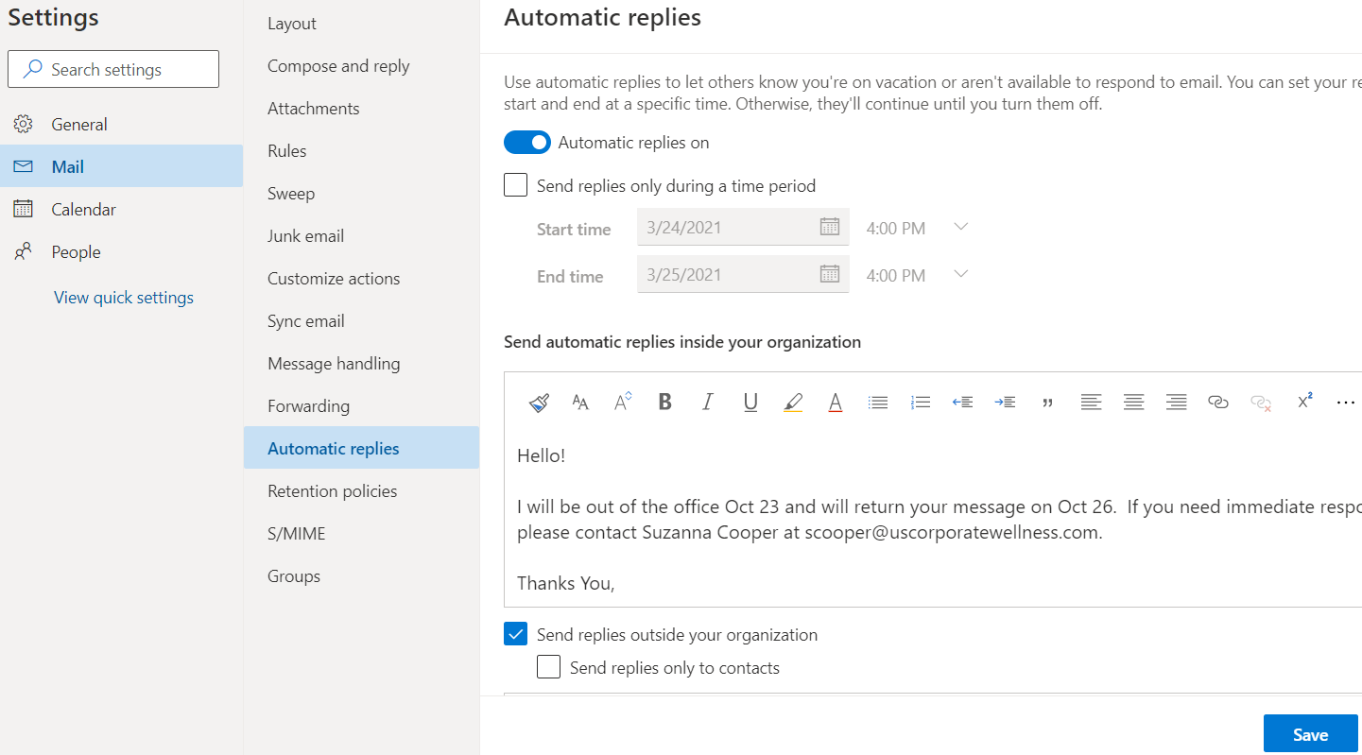

- Sample vacation notice on your calendar:
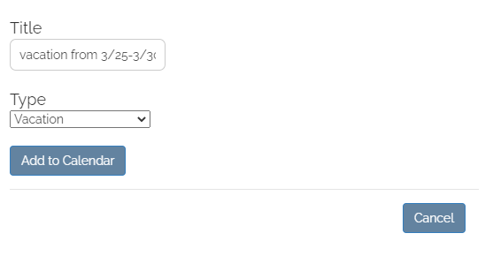
New Clients
- New clients will schedule on the calendar directly.
- A notice will be emailed to you.
<Client> has added or updated their call appointment. Please sign in and use the url below to go to the date of the new appointment.
https://www.uscorporatewellness.com/member/calendar/?yr=2021&mth=3&date=16

When you log on to the website, on the Wellness Journal page, you will see a banner with the following: (Click dismiss)

Transfer Clients
- A notice about new clients will be e-mailed if new clients have been assigned to you that day.
You have new clients! Please complete the following steps to accept your new clients:
1. Use the URL below to view your new clients
2. Click on your new clients in the table to select them
3. Click 'Accept Selected Clients' on the bottom right
https://www.uscorporatewellness.com/member/admin/?show=new
- When you log on to the website, on the Wellness Journal page, you will see a banner with the following: (Click dismiss)

Accepting New and Transfer Clients
- In Coach Admin, click on ‘Filters’ and then ‘Only new clients’
- If you are keeping a master excel spreadsheet of all of your clients, you will want to click ‘Export’ and then copy/paste these new clients into your master list - Do NOT click ACCEPT NEW CLIENTS before exporting them!
  - Click on ID number, and it will highlight the ID(s) and then you can click ‘Export’
- Click “Accept Selected Clients”
  - Once you ‘accept’ them they will merge with all of your other clients
Technology Integration

USCW Calendar Merge with Personal Google Calendar
- Log in to the USCW Calendar
- In the Month view on the top right, click on ‘Subscribe to calendar’
- Copy URL link
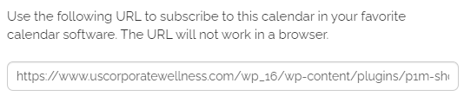
- Open your personal Google Calendar
- On the left side menu bar at ‘Other Calendars’ click on ‘+’ ‘add other calendars’
- Click on ‘From URL’
- Paste in the copied URL
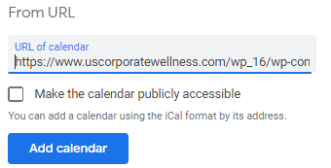
- Click ‘Add Calendar’
- Rename the new Calendar to USCW
- At the new USCW URL calendar, on the left, click on the 3 dots , by the X
- Click on ‘Settings’
- Rename the calendar
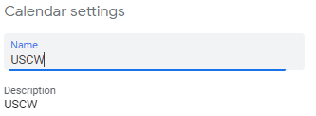
- Close the calendar completely and open back up and you should see the new name and USCW calendar merged with your personal Google calendar.

Texting from an Android phone on your computer (This can also be done through the i Phone as well)
This is a great tool to use to text on your computer instead of your phone.
      - Install Google messages SMS app installed from the Google Play Store.
      - Open app and set it as default SMS/Texting App (application will ask you).
        - This will now become your new texting app for your phone.
      - On your computer type www.messages.google.com
        - Follow the instructions on how to set up.

SOAP Note (Client Documentation)

You will only use these 4 icons: Notes Edit Profile Accept clients to login as your client

In the SOAP Notes page, you will only use of the icon from the top:

- 2 ways to get into the SOAP Notes
  - Log on the calendar
    - click on client name then ’Start Note’
    - click on ’Notes’
  - In the Admin area, enter client name in the ‘Search’
    - click on ’Notes’
- To keep the calendar and SOAP open
  - At the Notes icon, right click and ‘open link in new tab’.
- Fill out the SOAP Notes entirely.
- Please note that sessions must be 15 minute minimum to count as a session.
- Always check to see if the SOAP saved properly – it is very important our clients get credit for their call.
  - Click on Note history
  - Make sure your note is ‘Posted’ and ‘Call Completed’ is noted.
  - Make sure you click Submit on the SOAP of every client you coached.
- 2 ways to schedule the next wellness coaching call appointment while in SOAP Notes:
  - At the top of the note, ‘Click here to go to calendar’.
  - After clicking “submit” you will see the prompt, “Note saved and posted! Click here to set next appointment”.
    - This link will take you directly to the calendar.
- To leave notes within a client’s SOAP that may be helpful information to the coach (e.g., date and time voicemail or text was left after a missed call), type the notes on the SOAP and let the SOAP save as a draft. Do NOT click Submit as this may “post” the note and possibly transmit to the corporate client, such as Welltok.

**Contract Info Button: provides info about the client
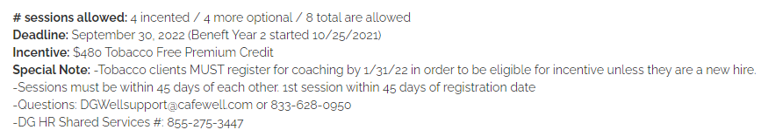

**Expiration date: this date shows up for the EAP clients – Mines & Concern

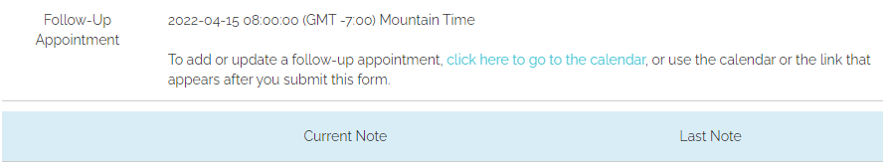
*** calls are scheduled in Coach’s timezone

SOAP Note Format
SOAP an easy-to-understand process of capturing the critical points during an interaction. Good notes make it easier for you to track each client’s progress over time and plan for future growth.

Subjective
- This section is dedicated to the qualitative information you gather from the client’s point of view.
- It is 1-2 sentences in quotation marks reflecting a statement the client made.
- Subjective data may include their perception of progress, issues they continue to struggle with, gains they feel good about, and any goals they have for future sessions.
- Opening up the session by asking how things are going can yield a rich amount of subjective data.
- Examples:
  - “I slept 6 hours in a row recently and I haven't slept that many consecutive hours in years.”
  - “I've been doing intermittent fasting now for about two weeks. After the holidays I felt I needed it. It's amazing how much I trim so fast.”
  - ” I'm looking forward to doing my miles and at night I walk hills. That helps me a lot, I can really feel it in my bones.”

Objective
- Write the things you talked about, what they are currently doing and client’s demeanor on the call.
- Document all the things you want to remember about the client for the next call.
- Examples:
  - Met with dietitian on Thursday - 4 days ago. She gave her a list of foods she could eat.
  - She has an app that calculates food and macros.
  - Still feeling anxiety and stress from work.
  - New manager isn't communicating well.
Assessment
- Your personal opinion or feeling about the person’s motivation.
- Stages of change documented.
- Example:
  - Client is in Contemplation for snacks, circle back to cutting down own milkshakes…Circle back next call.
  - She seems to be doing well. She stays pretty consistent in the way she cares for herself.
  - She currently is concerned for her son as he is not feeling well in basketball, and she says she feels his stress.
  - She did mention that exercise consistency seems to help her sleep better.
  - In my assessment, she doesn't think this is a problem but mostly something she just accepts as what someone in night shifts struggles with.
  - I did try to talk with her about upcoming barriers like a schedule change and job change.

Plan
- SMART goals
- What will be the goal for the next session?
  - Did the session reveal a need for any other goals to be talked about in future sessions?
  - Are there any challenges relating to the goals?
- Examples:
  - Always have on hand the types of foods you like. Grocery shop with that in mind.
  - Stay the course 140g of carbs and 10g of saturated fat replacing red meat with chicken.
  - Aim to drink 80 ounces of water a day.
  - Continue working out 4 days a week for 30-45 minutes after work.
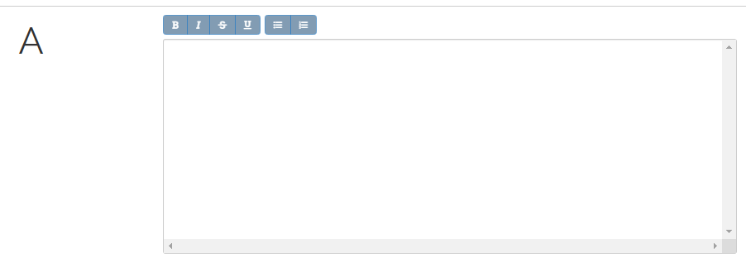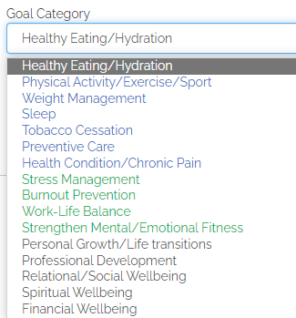
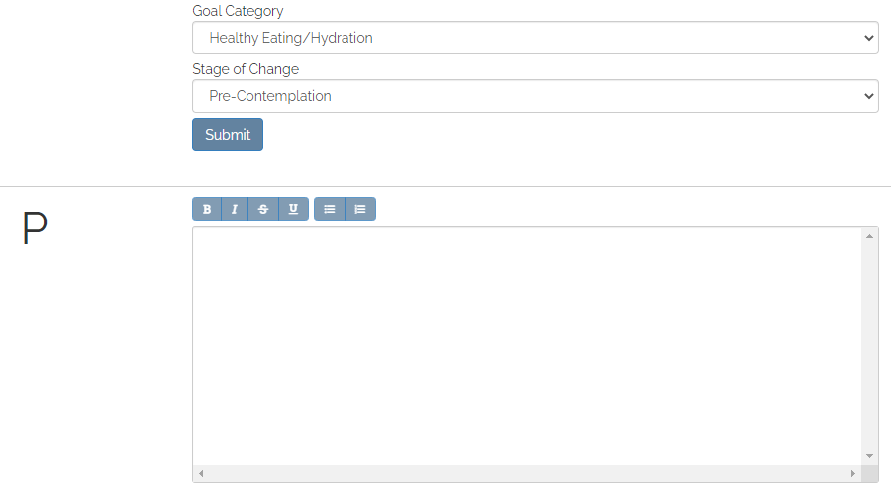
For the Goal Category DropDown box, coach should mark the PRIMARY goal of the client FIRST. Coach is allowed to choose more than one category per client; just ensure the primary goal of the client is chosen first, as this affects reporting.

Goal Category Description

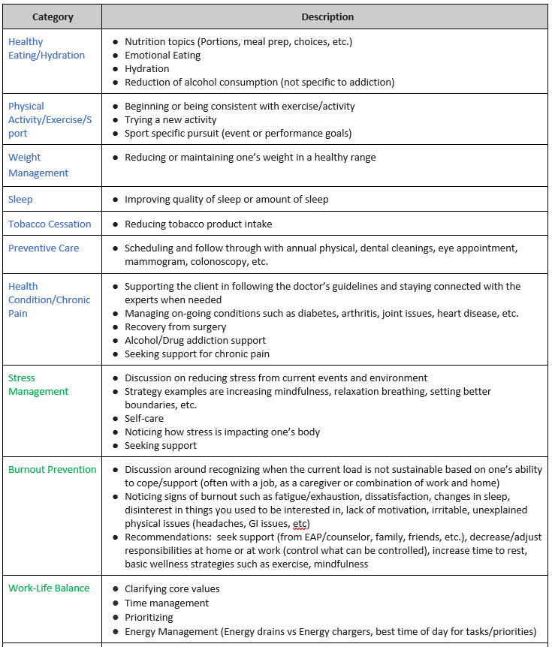

Goal Category Description

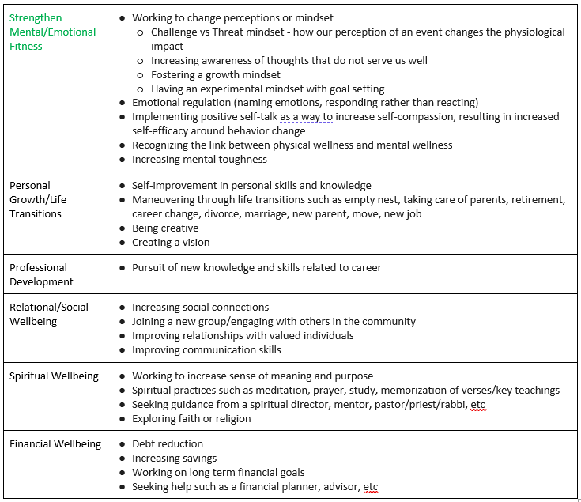

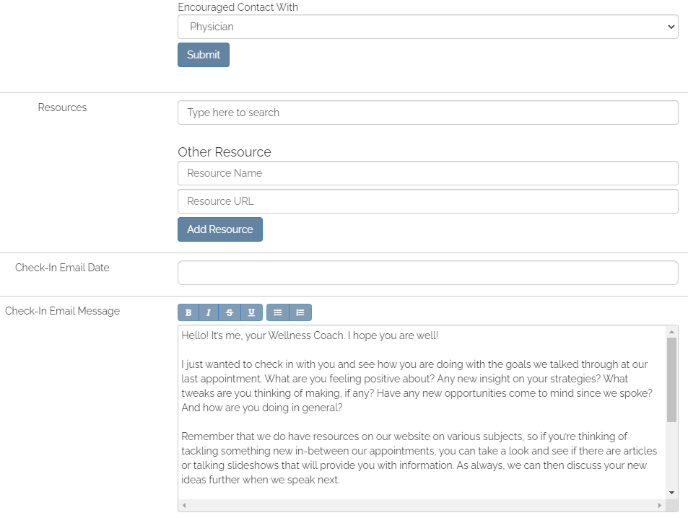
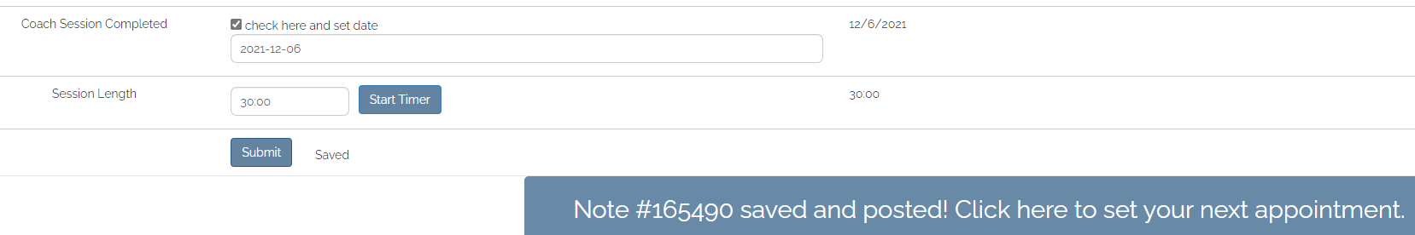

***Soap History button
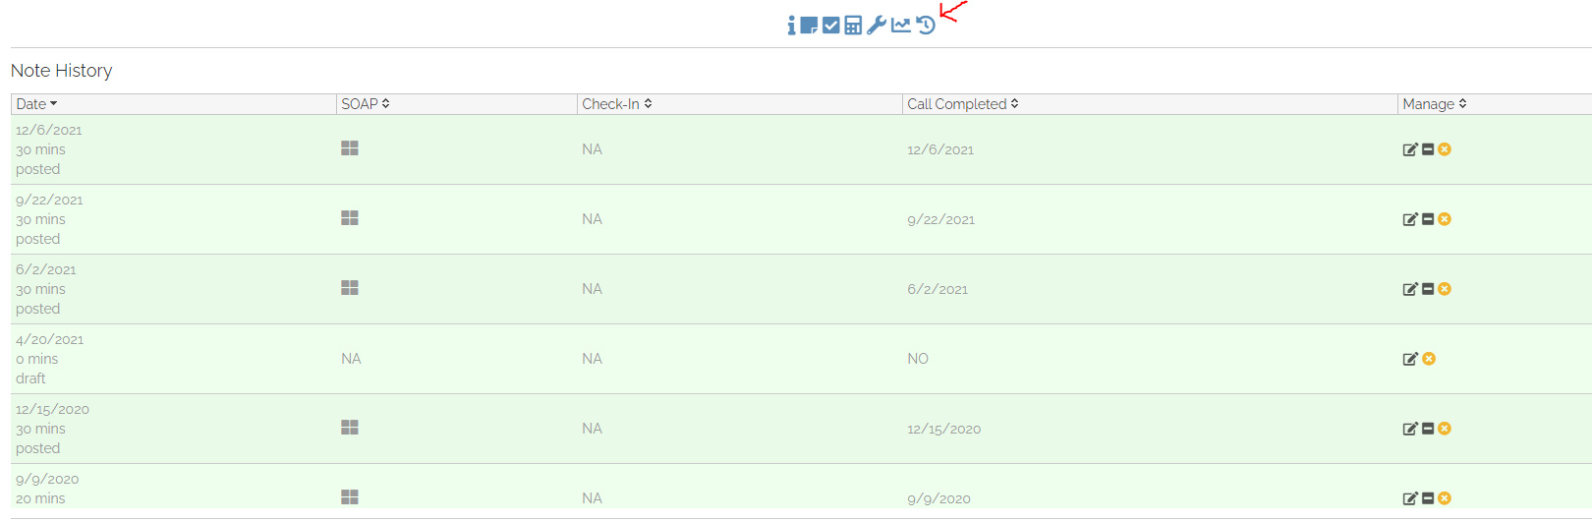
Reporting
On all reports, click ‘Admin’ then ‘Filters’:
- YouTube video link https://youtu.be/-hDa98526vE

Active Client List
- Filter by ‘Only Active Clients’ and ‘Only My Clients’
- Leave everything else blank
- Click ‘close’
- Click ‘export’

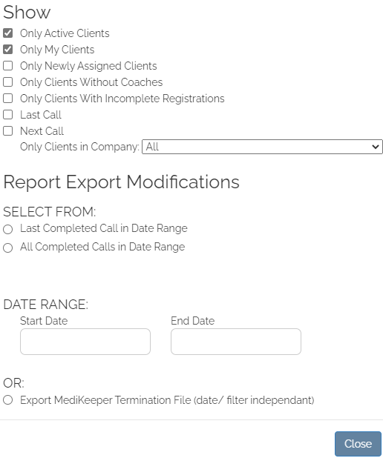
- Export to excel – bottom left-hand corner or top right-hand corner.
  - This creates a spreadsheet of all of your client’s information.
    - The export will include whatever category in which you have filtered your clients above so if you want all of your clients, be sure the “Only Client in Company” search box to filter is blank.
  - Click on the spreadsheet generated at the bottom left of the menu bar.
  - Click ‘Yes’

  - Enable Editing

  - Sort clients by a specific column
    - Highlight the data you want sorted
    - Click ‘Data’, ‘Sort’ then you can sort by columns

Sort by Company
- In the Type in the name of the company in the Search box and it will show only that company.
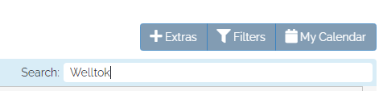
- Export to excel – see above instructions.

View Inactive, Leave, and Terminated Clients
- Check the box ‘Only My Clients’
- Leave all other buttons blank
- Click ‘close’
- Click ‘export’
- Export to excel – see above instructions
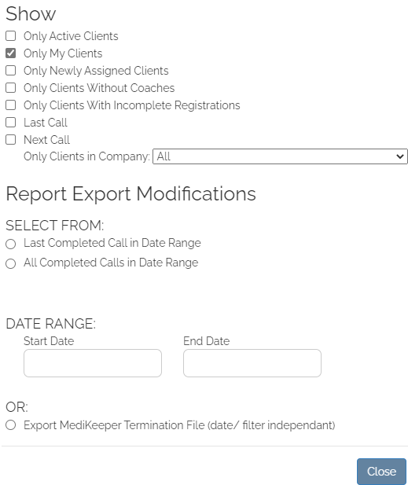
Viewing clients’ Number of Completed Sessions by Contract
(For example, when trying to see which DG Tobacco or Well-Being clients have less than 4 completed sessions.)
- Ensure you are on Admin page by clicking Admin in upper left of USCW site.
- Click Filters.
- Ensure Only Active Clients box is checked.
- Ensure Only My Clients box is checked.
- In the drop-down box under Only Clients in Company, scroll down to desired contract name.
- Select button for All Completed Calls in Date Range.
- Choose desired date range (start date and end date).

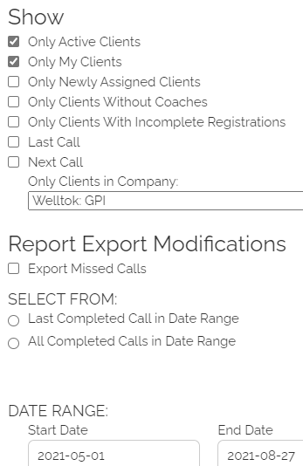

- Click Close.
- Back on Admin page, click Export button in lower left-hand side of page.
- Click on generated Excel spreadsheet.
- Answer Yes to the dialog box that pops up.
- Click “Enable Editing” in the dialog box that appears at the top.
- Delete columns on spreadsheet that are unnecessary to view (COID, DOB, phone #’s, DEPT, POSITION, etc.).
- Put cursor in A2.
- Click Sort & Filter, scroll down to Custom Sort.
- Sort by Total Calls with an order of Largest to Smallest.
- You will be able to see the clients and their number of completed calls, along with the dates of the calls.
- You will also be able to see if they have a “next call” scheduled.

Invoice
End of Month Completed Call Audit
- Purpose – Check to ensure that all calls that were scheduled and NOT marked as Missed on coach calendar show up as completed calls on reports. This is how USCW invoices corporate clients. This report is also how your invoice should be generated.
- YouTube video link https://youtu.be/-hDa98526vE
- Each month you will send Suzanna your invoice indicating the calls you had, meeting, or any other billable activities.
Important Due Dates
- By the 3rd of each month: audit coaching calls for the previous month.
  - For example, run the report (as described below) and compare to your coaching calendar to ensure that every call on your calendar shows up as completed in the report.
- By the 10th of each month: send your invoice to Suzanna.

Directions
- Ensure you are on Admin page by clicking Admin in upper right of USCW site.
- Click Filters.
- Ensure Only Active Clients box is NOT checked.
- Ensure Only My Clients box is checked.
- In the drop-down box under Only Clients in Company, choose All.
- Select button for All Completed Calls in Date Range.
- Choose monthly date range (start date and end date).
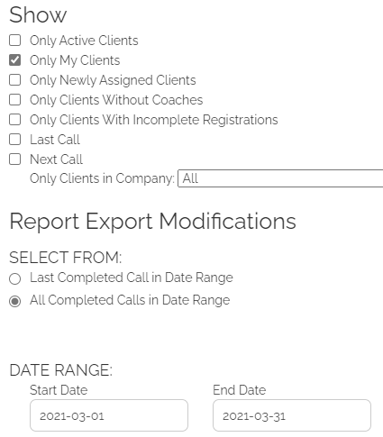
- Click Close.
- Back on Admin page, click Export button in lower left-hand side of page.
- Click on generated Excel spreadsheet.
- Answer Yes to the dialog box that pops up.
- Click “Enable Editing” in the dialog box that appears at the top.
- Delete columns on spreadsheet that are unnecessary to view (COID, DOB, phone #’s, DEPT, POSITION, etc.).
- Put cursor in A2.

- Click Sort & Filter, scroll down to Custom Sort.
- Sort by Completed Calls.
- Check this report that shows calls by date against the month for which you are auditing calls.
- If there is a scheduled appointment on your calendar, but not on the generated report, it means your SOAP was not correctly submitted. There is some type of error, or the SOAP is still in Draft mode.
  - Find the client’s SOAP.
  - Check the Note History for the date that is missing.
  - Solve the mystery of why the SOAP has not showing up as a successfully completed call.
  - You may need to Edit the SOAP – and click Submit – if it’s just showing as a DRAFT still.
  - Contact me if you are having trouble solving the mystery of the SOAP not showing on your report.
  - Run a new report after you think you have solved the issue to ensure the call shows up as completed.
- You can copy and paste desired columns and rows into your monthly invoice.

Miscellaneous

Preventative Measures for Website Outage
It can be helpful to have back-up procedures in place.
- Screenshot your USCW calendar at regular intervals.
- Have a recent report exported of your clients with all their info.
- Upload the USCW calendar to Google Calendar. This will show client names, but not phone numbers.
- And for most recent new clients, if the coach has sent an intro email, the coach could at the very least find the email address of recently registered clients from their sent emails.

Setting up USCW Email Signature
- In Outlook, click on Settings
- Search ‘email signature’
- Set up your email signature:

<Coach Name, any Letter Credentials>
National Board-Certified Health & Wellness Coach
US Corporate Wellness, Inc.

** Recognized by URAC as one of the nation's first Fully Accredited Comprehensive Wellness Providers **
This e-mail contains information that is confidential and may be privileged. It is intended only for the addressee(s) named above. If you receive this e-mail in error, please do not read, copy or disseminate it in any manner. If you are not the intended recipient, any disclosure, copying, distribution or use of the contents of this information is prohibited. Please reply to the message immediately by informing the sender that the message was misdirected. After replying, please erase it from your computer system. Thank You.

Appendix
Sample Autogenerated Emails for Ohio Health
Appointment Confirmation Email
Hello,
Thank you for scheduling a wellness coaching call for [APPOINTMENTTIME].
If this is your first coaching call, please read below for a brief description of what to expect, along with tips on how to maximize the experience.
Your own personal wellness coach
- My name is [COACHNAME], and we get to connect up to four times before December 31, 2022.
- Our calls will take about 20-30 minutes - and during our call I will help you focus in on the things you see as important and help you design strategies to achieve your personal health and wellness goals. One thing I won’t do is make you feel guilty!
- I will call you at the time you scheduled. Please note that I have set this time aside just for our coaching session; if you are no longer able to keep this appointment, please send me an email at [COACHEMAIL] to reschedule. You may also log back into http://ohiohealth.cafewell.com, click the Action Card for coaching, and reschedule at your convenience.
Make your coaching call the best experience possible
I know your time is valuable, so in order to maximize our time together and obtain the best coaching experience possible, please take a minute to consider the following:
- What would you like to stop, start, or improve about your current health and wellness?
- Wellness includes a variety of areas such as the following: healthy eating, exercise, weight management, tobacco cessation, stress management, sleep, life balance, personal growth, and professional development. What are one or two areas from this list that you would like to focus on during our first session?
- If you have the results of a health assessment or any recent bloodwork, it may be helpful to review it for possible items to discuss during our call. Coaches are not here to take the place of your doctor, but we are available to help you determine any goals in areas of health you may deem a priority.
Let me know if you have any questions. I look forward to talking with you soon!
Respectfully,
[COACHNAME]

Missed Call Email

We were scheduled to connect for your Wellness Coaching appointment today [APPOINTMENTTIME], and we were unable to complete the call at that time. Please remember that I have set this time for you, and if you cannot make the appointment, please alert me before the scheduled time.
To reschedule, click this link to connect to my calendar and reschedule your coaching call there: http://ohiohealth.cafewell.com and selecting the Action Card for Wellness Coaching. After that, you will be able to see the coaching calendar. You may also reschedule by responding to this email and letting me know days/times that are best for an appointment, and I will try to find a time that matches with your schedule.
I look forward to meeting with you!
Respectfully,
[COACHNAME]

